Computer Vision HW9

姓名：周秉儒

學號：r07922166

各式各樣的edge detection

Robert : threshold = 22

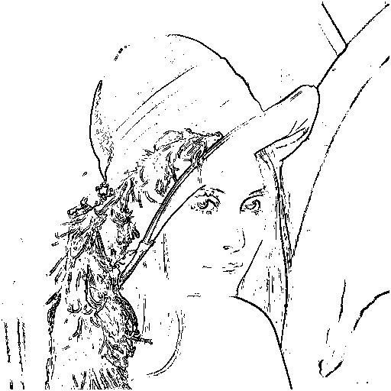

Prewitt : threshold = 42

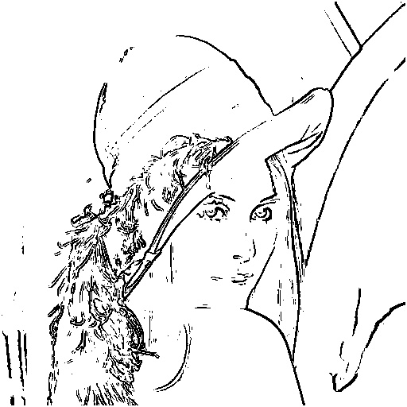

Sobel : threshold = 38

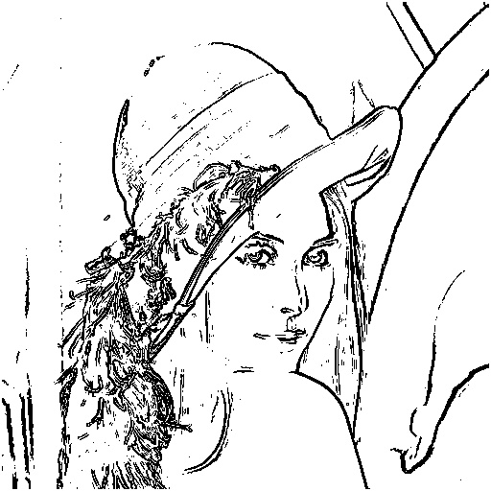

Frei and chen : threshold = 40

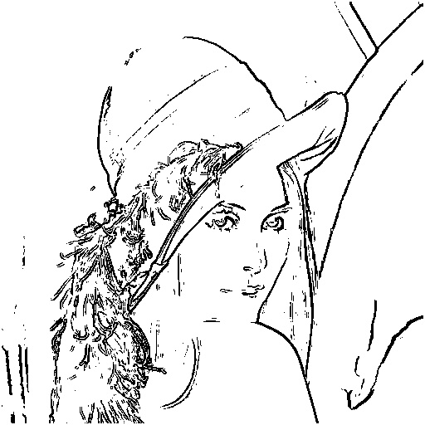

Kirsch : threshold = 125

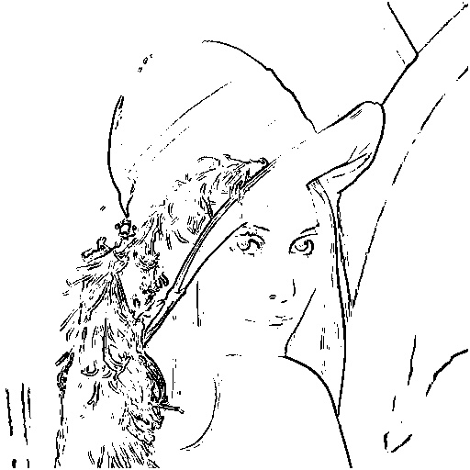

Robinson : threshold = 36

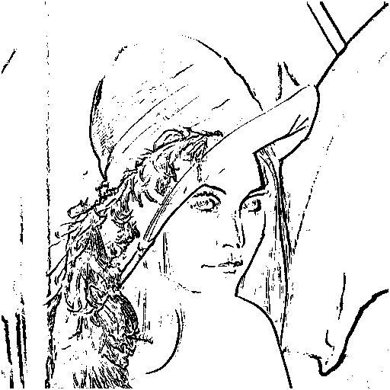

Netavia and babu : threshold = 15400

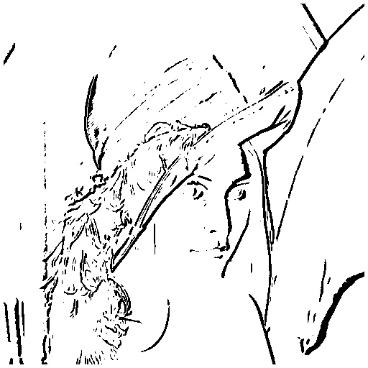

程式碼：

Robert :



Prewitt:



Sobel:



Frei and chen:



Kirsch:



Robinson:



Netavia and babu:

